STEP 1: Create Gmail App Password (Required)
Since you're using Gmail, you must create an App Password.
Go to: Google Account → Security
Enable 2-Step Verification (if not already enabled)
Click App passwords
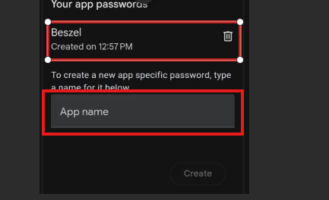
Copy the 16-character password (example: abcd efgh ijkl mnop)
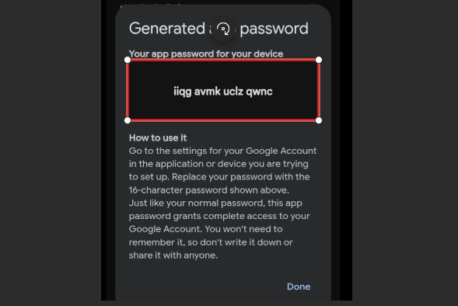

STEP 2: Configure SMTP from Beszel UI
Login to your Beszel Dashboard
Go to: http://<beszel-host-IP>:8090/_/#/settings/mail

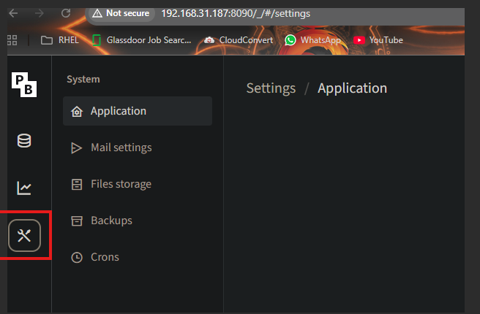
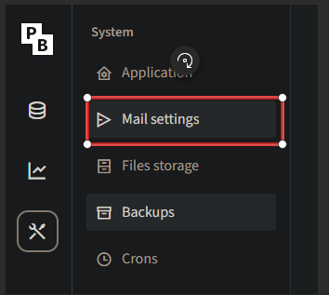

Sender name Beszel-Support (Your Defined Name)
Sender address which account you wish to use (Switch on Use SMTP mail server )
SMTP server host smtp.gmail.com (I have used my gmail to test)
Port 587
Username used gmail address
Password app password generated in gmail account in step 1

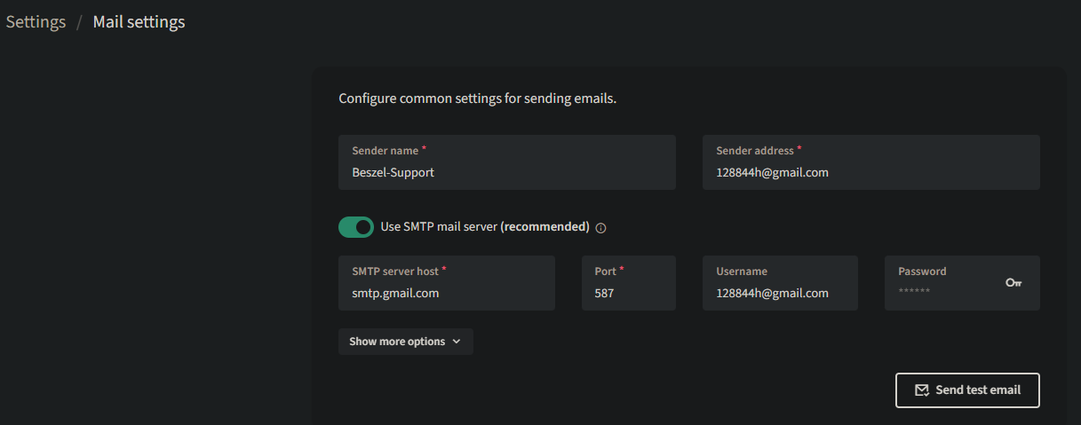

Step 3: Now test the mail configuration
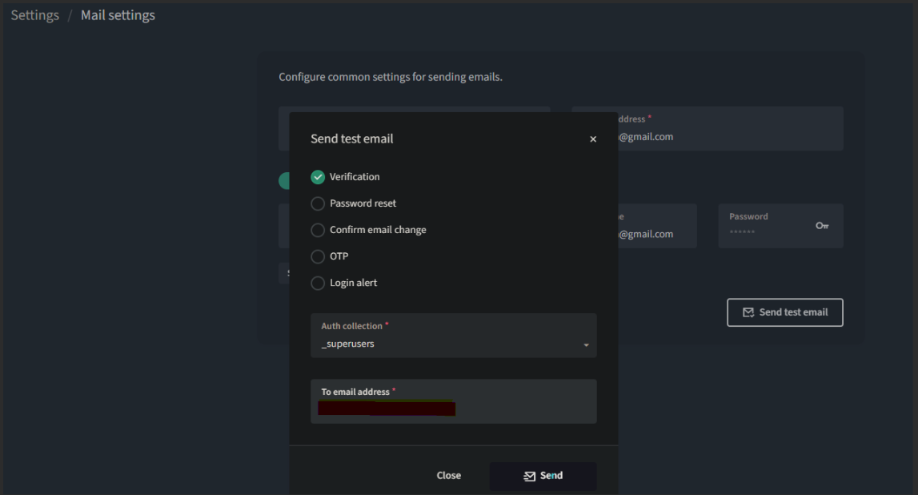

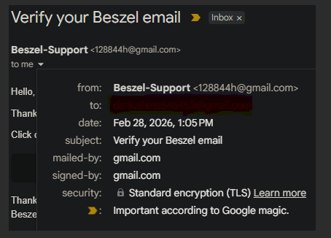

--------------------THANK YOU--------------------

